<!DOCTYPE html>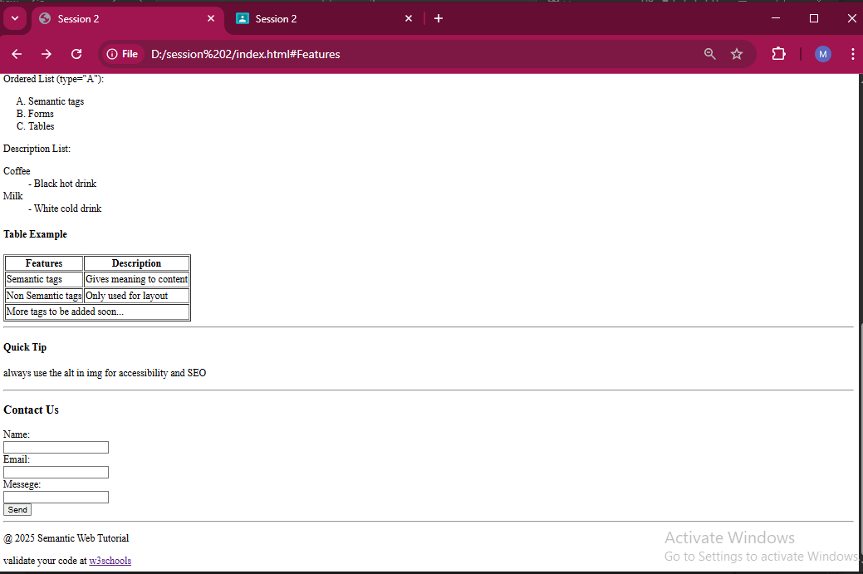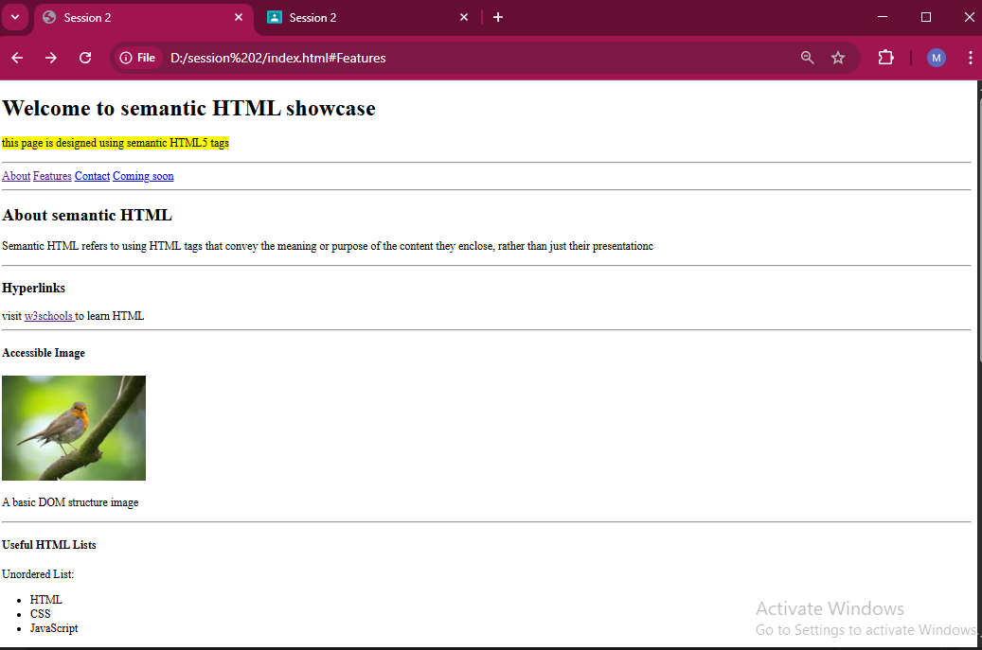

<html lang="en">

<head>

    <meta charset="UTF-8">

    <meta name="viewport" content="width=device-width, initial-scale=1.0">

    <title>Session 2 </title>

</head>

<body>

    <h1> Welcome to semantic HTML showcase</h1>

    <p> <mark> this page is designed using semantic HTML5 tags</mark></p>

    <hr>

    <header>

        <nav>

            <a href="#About">About</a>

            <a href="#Features">Features</a>

            <a href="#Contact">Contact</a>

            <a href="#Coming soon">Coming soon</a>

        </nav>

    </header>

    <hr>

    <h2>About semantic HTML </h2>

    <p>

        Semantic HTML refers to using HTML tags that convey the meaning or purpose of the content they enclose, rather

        than just their presentationc

    </p>

    <hr>

    <h3>Hyperlinks</h3>

    visit <a href="https://www.w3schools.com/"> w3schools </a> to learn HTML

    <hr>

    <article>

        <h4> Accessible Image</h4>

        <img src="download.jpeg">

        <p> A basic DOM structure image</p>

    </article>

    <hr>

    <h4>Useful HTML Lists</h4>

    Unordered List:

    <ul>

        <li>HTML</li>

        <li>CSS</li>

        <li>JavaScript</li>

    </ul>

    Ordered List (type="A"):

    <ol type="A">

        <li>Semantic tags</li>

        <li>Forms</li>

        <li>Tables</li>

    </ol>

    Description List:

    <dl>

        <dt> Coffee </dt>

        <dd> - Black hot drink</dd>

        <dt> Milk</dt>

        <dd> - White cold drink</dd>

    </dl>

    <h4> Table Example</h4>

    <table border="1">

        <tr>

            <th> Features</th>

            <th> Description</th>

        </tr>

        <tr>

            <td> Semantic tags</td>

            <td> Gives meaning to content</td>

        </tr>

        <tr>

            <td> Non Semantic tags</td>

            <td> Only used for layout</td>

        </tr>

        <td colspan="2"> More tags to be added soon...</td>

    </table>

    <hr>

    <div>

        <h4> Quick Tip </h4>

        <p> always use the alt in img for accessibility and SEO </p>

    </div>

    <hr>

    <h3> Contact Us</h3>

    <label for="name">Name:</label>

    <br>

    <input type="text" id="name" name="name">

    <br>

    <label for="email">Email:</label>

    <br>

    <input type="text" id="email" name="email">

    <br>

    <label for="messege">Messege:</label>

    <br>

    <input type="text" id="messege" name="messege">

    <br>

    <button> Send </button>

    <hr>

    <footer>

        <p> @ 2025 Semantic Web Tutorial </p>

        validate your code at <a href="https://www.w3schools.com/"> w3schools </a>

    </footer>

</body>

</html>